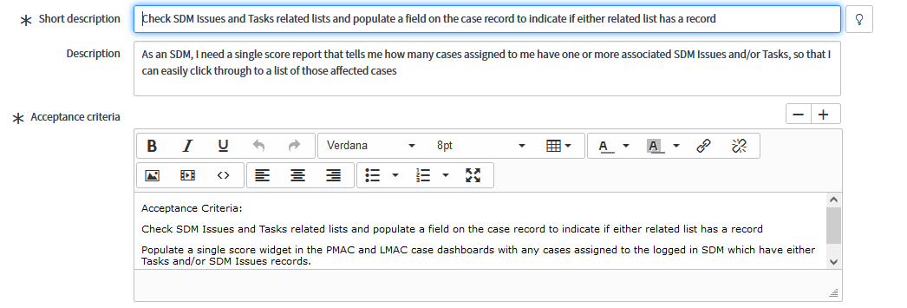

Description : As an SDM, I need a single score report that tells me how many cases assigned to me have one or more associated SDM Issues and/or Tasks, so that I can easily click through to a list of those affected cases.

UAT : Acceptance Criteria:

Check SDM Issues and Tasks related lists and populate a field on the case record to indicate if either related list has a record

Populate a single score widget in the PMAC and LMAC case dashboards with any cases assigned to the logged in SDM which have either Tasks and/or SDM Issues records.

